**TASK 1**

1. Jupyter notebook:

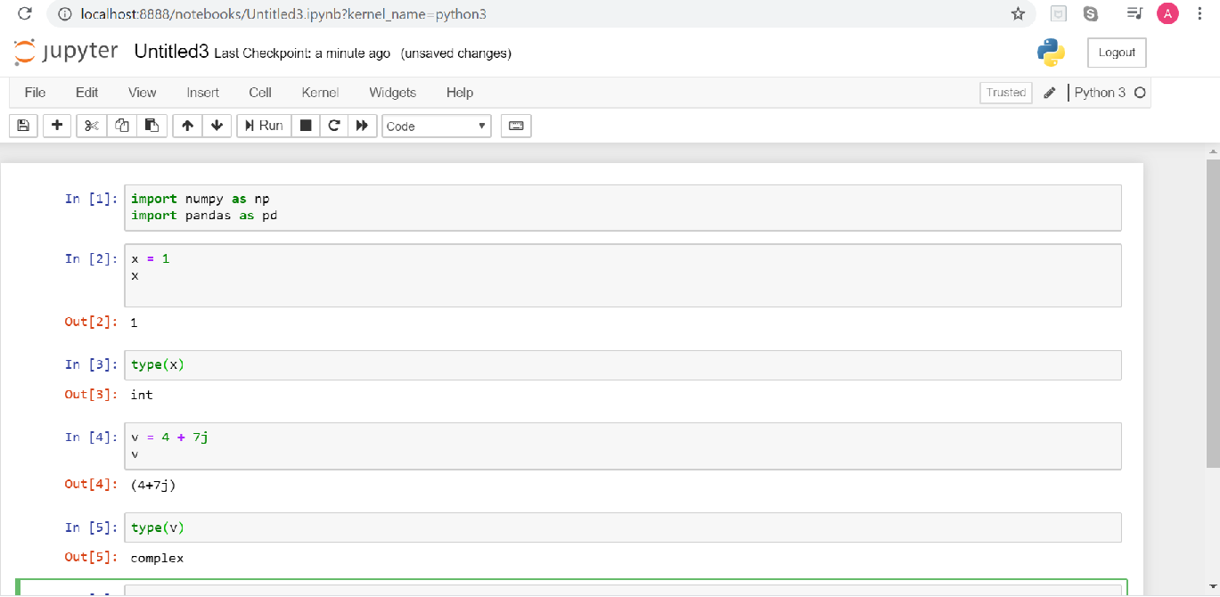

1. a = []

for i in range(2000, 3200):

if (i%7==0) and (i%5|0):

a.append(str(i))

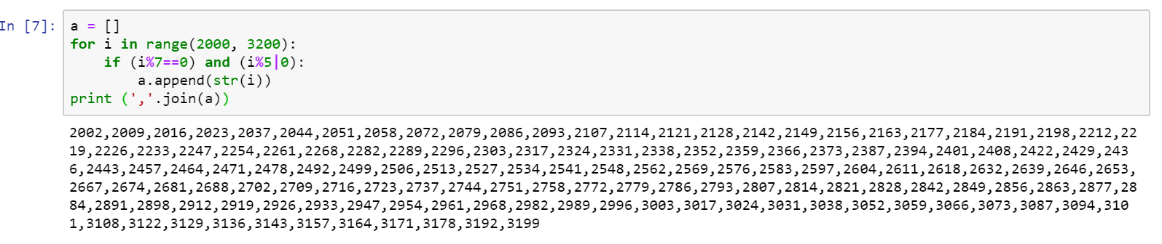 print (','.join(a))

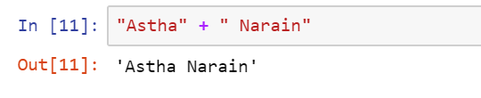

1. 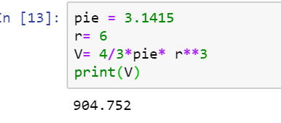

**Task 2**

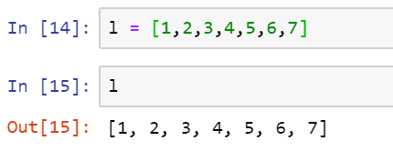

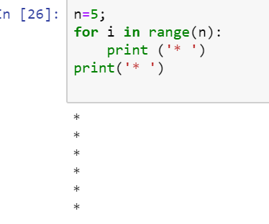

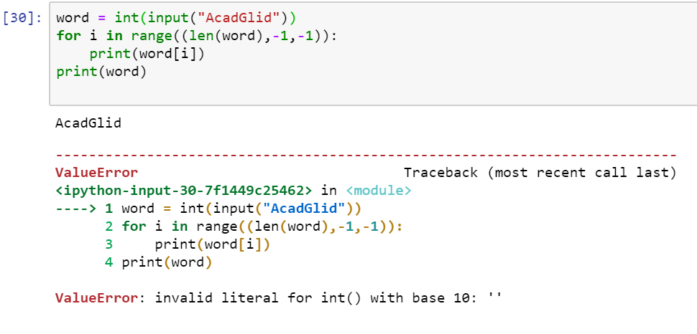

1. print("WE, THE PEOPLE OF INDIA, \n\tHaving solemnly resolved to constitute India into a SOVEREIGN! \n\t\tSOCIALIST, SECULAR, DEMOCRATIC REPUBLIC, \n\tand to secure to all its citizens")

